Kid’s Tech University Presents:

CELLS



Module Instructions &

Supplemental Material



**Introduction:**

Welcome, Instructors and Parents, to The Virtual Kid’s Tech University’s *Cells* Module! The goal of The Virtual Kids’ Tech University is to improve science literacy in primary education to ensure a strong STEM workforce of tomorrow. KTU targets elementary and middle school students at a critical point in their education where they may be intimidated by science and introduces them to a variety of fields through interactive modules and lessons online. This module, *Cells*, is designed to connect students, instructors, and the scientific method into a cohesive lesson that is both fun and interactive for students. While using KTU’s *Cells* module, students are taken through a virtual cell where they are given explanations, real-life images, and interactive activities to solidify their understanding of each objective in the module. This module can be applied in a formal setting or in an informal setting, allowing flexibility for both instructors and students.

**Incorporated 2012-2013 Virginia Standards of Learning**

This module incorporates the following Standards of Learning for 4th-7th Grade under the Virginia Standards of Learning; **Matter, Living Systems, and Cells.**

|  |  |  |
| --- | --- | --- |
| 5th Grade | 6th Grade | 7th Grade |
| * **5.4 c.** Atoms and elements * **5.4 d.** Molecules and compounds * **5.5 a.** Basic cell structures and functions | * **6.4 a.** Atoms consist of particles, including electrons, protons, and neutrons * **6.4 b.** Atoms of a particular element are alike but are different from atoms of other elements * **6.4 d.** Two or more atoms interact to form new substances, which are held together by electrical forces (bonds) | * **LS.2 a.** Cell structure and organelles * **LS.2 c.** Development of cell theory * **LS.2 d.** Cell division * **LS.3 a.** Cells, tissues, organs, and systems * **LS.3 b.** Patterns of cellular   organization and their  relationship to life processes in  living things |

**Included Lesson Materials:**

Included in this document are all of the tools you will need to complete this lesson with your class. The following materials are incorporated within this lesson:

* **Online Module Link** – The link for the online module provides access to the online version of the module, which includes the lesson, interactive activities, review games and more!
* **Online Jeopardy Game**: At the conclusion of the online module there is an interactive jeopardy game that asks students questions based on the content of the module. There is a “Quick” version (aimed at 4th-5th Graders) and a “Full” version (aimed at 6th-7th Graders).
* **Supplemental Instructor’s Notes** – In the Supplemental Materials section of this document there are Instructor’s Notes that provide additional information and key points for each page of the module. (These notes are also included in the PowerPoint document).
* **PowerPoint Lesson** – Provides identical information as the online module in the form of slides, to allow for a lecture-based lesson. The document also includes instructor’s notes in the notes section on PowerPoint.
* **Follow-Along Worksheet** – Guides students through the online module by giving step-by-step instructions and fill-in-the-blank sentences that coordinate directly with the information in the lesson.
* **Applied Learning Worksheet (Standard and Advanced Versions)** – Provides questions that help students review the information from the module and apply what they have learned. There are two different difficulty levels for the worksheets; standard and advanced.
* **Applied Learning Questions** – The questions asked in the online jeopardy game are also included in this document in the form of Applied Learning Questions. These can be used for testing students or reviewing.

**Instructions:**

This module can be employed in two different settings: via computer or as a lecture. This module is primarily designed for online use because of the interactive activities; however, this lesson plan also provides identical information to the online module in a PowerPoint document to be given as a lecture. When using the lesson in a lecture format, you will need to have the capability to project the PowerPoint document provided for this module on to a projector screen for the student(s), accompanying your verbal lecture. If the Lesson will be used via computer, make sure to run the program on a compatible web browser (Chrome, Safari, Firefox, and Internet Explorer 10+ are all compatible). If there is a default setting for the browser on the computer(s) you will be using, be sure to have the scripts unblocked before running the module.

At the conclusion of the online module, there will be a Jeopardy game, featuring a “quick” and “full” version. The quick version features fewer and simpler questions, whereas the full version incorporates more questions, all of which are slightly more difficult. It is highly encouraged that when your students play this, they pay attention to the link that will appear on the boxes of questions they answer incorrectly. These links will take them to the page that explains the question they just missed, allowing them a final opportunity to learn the material before moving on to the rest of the game.

**Supplemental Materials Table of Contents:**

* **Pages 5-8:** Supplemental Instructor Notes
* **Pages 9-12:** Follow-Along Worksheet
* **Pages 13-14:** Standard Cells Worksheet
* **Pages 15-16:** Advanced Cells Worksheet
* **Pages 17-19**: Follow-Along Worksheet Answer Key
* **Page 20:** Standard Cells Worksheet Answer Key
* **Pages 21-22:** Advanced Cells Worksheet Answer Key
* **Pages 23-24**: Applied Learning Questions

**Supplemental Instructor Notes:**

Below is a list of notes that have been formatted to be coordinated on a slide-by-slide basis. These notes are also located in the notes section under each slide on the PowerPoint document for this module if you prefer to look at them in context. There are **not** notes for every single slide; *the notes below are titled with the identical title from the coordinating slide in the PowerPoint document or virtual model*. It is necessary that you familiarize yourself with the online module and review these notes before hosting a computer lesson or lecture for the class.

**“Cells; A Very Big World is Made from Very Little Helpers”:**

Make sure to complete a verbal introduction accompanying this intro slide, such as: “Today we will be learning about cells, they are the smallest units of all living things on earth (-That perform all of the basic functions of life-)!”

**“Building Blocks”:**

This chain is to show where cells fall in regards to the building blocks of life. At the most basic level, atoms make up everything that is matter. Molecules are groups of atoms joined together. When you focus on living things, cells are the smallest unit of an organism that does all the processes required for life (like making proteins and using energy). We later break the cell down into different parts that work together, but the takeaway is that the kids understand about where cells fall in relation to atoms and molecules. Strongly discourage the notion that Atoms and Cells are the same. Make sure that students realize that cells are made from atoms and molecules but atoms and molecules are NOT made from cells. They also must understand that atoms make up every single substance on earth; living and nonliving, whereas cells only make up living organisms.

**“Atoms”:**

This is an optional slide to go more in-depth with atoms. When explaining Atomic number and elements, it is important to give the students a visual of some type of periodic table of elements to refer to. Also verbally describe a few examples of elements, such as hydrogen, oxygen and carbon. Make sure that students understand that these elements are all different because of the number of protons they have.

This may be a good time to talk about the difference between elements and compounds. Water is a compound because it is made up of two different elements (oxygen and hydrogen). Water can be broken down into these two elements using electrolysis. However, oxygen and hydrogen do not break down into other elements and you can’t combine them to make new elements with a chemical reaction.

**“Molecules”:**

This is an optional slide to go slightly more in-depth about molecules for the students. You want to make it perfectly clear to the students that molecules are composed of atoms. You may also want to describe some familiar examples to students, especially the H2O/water reference provided. Make a statement about molecules and atoms, emphasizing that those two entities are responsible for every material and thing found on earth. Don’t overwhelm them with too many examples but give them a mixture of living and nonliving examples and how they are made of different atoms & molecules. Metals can be single elements (and therefore made of all of the same atoms) or they can be alloys, which are mixtures of elements (like brass is a mixture of copper and zinc).

**“Cells Come in all Shapes and Sizes”:**

Emphasize to students that cells make up all living organisms in the world around them (plants, animals, and even their own bodies). Identify these images verbally and connect them to the parts of the body they are found in:

* + Fat cells are found under your skin.
  + Blood cells are found in blood, like when you scrape your knee & it bleeds, you’re losing blood cells.
  + Bone cells are found in your bones (like your skeleton) to make them strong and tough.
  + Nerve cells are connected from your brain to the rest of your body and can send messages throughout your body.

**“Microscopes”:**

Optical microscopes work basically like very powerful magnifying glasses. The lenses are able to focus on very tiny objects. It is difficult to put into perspective how tiny 550 nanometers is. Usually describing size works best when you create a comparison. One close comparison is that 550nm is about 1/3 the size of a single grain of salt. You can also say that 550nm to a basketball hoop (10 feet) is the same as one person to the diameter of the Earth).

There are many different techniques for electron microscopes, so avoid going into any detail here. In the future we hope to provide an additional electron microscopy page with the accompanying website for this module that hopefully will give the kids a stronger understanding if they are interested

**“Fat Cells”:**

Fat Cells are also important for cushioning the organs when you’re running or you fall down.

**“Nerve Cells”:**

Nerve Cells act extremely fast. This is why a reaction, like seeing a ball coming at you and ducking, can take place in under a second. (Most human reaction times are around 200-300 milliseconds. This is 0.2-0.3 seconds.) But your brain can recognize an image and process it in just 13 milliseconds.

Also, make sure to spend time going more in-depth with the diagram above. Explain to the kids how the nerve cells attach to one another and that it is like a relay throughout your body when a message is sent.

**“Bone Cells”:**

Your bones are always working to ‘refresh’ so to speak. Even though your bones stop growing larger when you get older, they are still working to replace bone tissue in order to keep them strong and fresh. There are two types of cells that work on this process (osteoclasts breaks down bone tissue and osteoblasts make new bone tissue). They work together to keep the bones healthy and strong. Most of the adult skeleton is completely replaced about every 10 years.

Often times children think about bones the same way they do fingernails because they are both hard tissue. However, they are not similar. Nails are a layered protein that the body makes and will just keep growing until they are trimmed. The nail part that you can see is not alive. Bones, however, are living. To give them an idea of how bones are living, you can let them know that their teeth are bones!

**“Blood Cells”:**

Why do veins appear blue when blood is red? Is oxygenated blood a different color from deoxygenated blood? The answer is that blood is a slightly different color when it is carrying oxygen versus when it is not. However, it is not as different as red and blue. Oxygenated blood is bright red whereas deoxygenated blood is more of a dark red (not blue). Your veins look blue because they are close to the surface of your skin. A thin layer of skin scatters blue light, which is the same phenomenon that causes the sky to look blue. (Air particles in the sky scatter blue light).

**“Nervous Tissue”:**

There are two main types of cells in nervous tissue. Neurons are the first that come to mind. They are the signal carriers and responders to stimulus. The other type of cell is kind of like a special connective tissue for the nervous system. These cells are called glial cells. They do not conduct signals but instead support, nourish, and protect the neurons. There are many more glial cells than neurons in nervous tissue.

**“Inside the Cell”:**

Explain to the students that you will be going inside of an animal cell. Make it clear that animal cells include everything that is not considered a plant, even us! Briefly read over the names of the organelles that you will be covering and let them know that you will be explaining each organelle following this cell. Make sure that they understand how organelles are to a cell what organs are to us, they are the parts that work together to keep us alive.

**“Cytoplasm”:**

The consistency of cytoplasm is difficult to understand. It has a lot of molecules dissolved in it which makes it pretty thick. The consistency is important because it allows molecules like proteins, sugars, and ATP (the energy carrier) to move around quickly, but it is still thick enough to keep organelles suspended. Smaller organelles (like lysosomes) move around a lot easier than larger ones (like the nucleus or endoplasmic reticulum). Some organelles are even held in place by fibers to keep them from moving. This helps the cell set up a network for moving materials around and compartmentalizing tasks.

**“Ribosomes”:**

How do ribosomes translate genetic information? mRNA (which is a copy of the DNA sent from the nucleus that the ribosome can read) goes to a ribosome where part of it is surrounded by the ribosome. The ribosome reads the mRNA three bits at a time. (These bits are one side of a base pair). The ribosome matches a tRNA to the 3-bit that has a complementary 3-bit base pair. This tRNA has an amino acid attached to it that the ribosome takes and hooks onto the next amino acid that is brought in. It keeps reading the mRNA 3 bits at a time until it has finished and hooked all of the amino acids together in the right order. This chain of amino acids is the correct protein. There is a good animation for this on Wikipedia on the Ribosome page (Figure 6) http://en.wikipedia.org/wiki/Ribosome.

**“Smooth Endoplasmic Reticulum”:**

Make sure that the students understand that there are 2 parts to the Endoplasmic Reticulum but that they do a very different job, that’s why we separate them.

**“DNA”:**

This is an optional slide that can be shown at any point (possibly after the Nucleus/Nucleolus/Ribosome sequence of slides to help the children understand a little bit more about how cells divide and why all of the information inside of the nucleus is so important to the cell’s well-being.

**CELLS Follow-Along**

(Most Suitable for 4th – 7th Grade)

Welcome to Kid’s Tech University’s lesson on CELLS! By going through this module you will learn about cells, how they function, what they are made of, and how they work to build all of the living things in the world around us! Follow through this worksheet to complete this lesson!

1. After looking at the first slide, click Next Page to take a look at the directions for this activity. Read everything the special cell friend is saying. What color will ‘clickable’ words be?
2. Continue to the Next Page and take a look at the “Building Blocks” listed. On this page there are Atoms, Molecules, and Cells. Read the entire page to fill in the blanks in the following sentences:
   1. __________________ are the basic components of the elements. Everything we see, living and nonliving, is made of atoms.
   2. Atoms combine to form ___________________.
   3. Just like atoms are the building blocks of molecules, molecules are the building blocks of ____________________.
3. Click on the link under Atoms that says, “Learn more about atoms!”. Read the information on the Atoms page to answer the following questions:
   1. Just like _________________ are the building blocks of living organisms, _________________ are the building blocks of all matter.
   2. _________________ carry a positive charge.
   3. _________________ carry a negative charge.
   4. _________________ carry a neutral charge.
   5. The atom has a ____________, which is where the protons and neutrons are found.
   6. The number of ________________ an atom has determines what element the atom is.
4. After you have finished the section on Atoms, click the Back button (on the bottom left corner of the slide) to return to the Building Blocks Page again. This time, click on the link above Molecules that says, “Can you guess which molecule this is?”. Read the page about Molecules to fill in the blanks in the following sentences:
   1. Molecules are groups of ________________ held together with a chemical bond (a strong ___________________ where the atoms share electrons.
5. After you have finished the section on Molecules, click the Back button (on the bottom left corner of the slide) to return to the Building Blocks Page again. This time, click on the link below Cells that says, “What do cells make up?”. Go through the following slides to help you fill in the blanks in the following sentences:
   1. ________________ perform the basic functions of life, such as making proteins, processing nutrients, and replicating.
   2. A group of cells with similar jobs combine to form __________________.
   3. When a group of similar tissues work together to complete a common task, they are called ____________________.
6. When you have read through all of the slides on the Cell section, press the Return button (on the bottom left corner of the slide) to get back to the Building Blocks page. From there, press Next Page to arrive at the “Cells Come in All Shapes and Sizes!” page. Press each of the pictures on this page to answer the following fill in the blanks:
   1. __________________ are tools that we use to see things much too small to see with just our eyes.
   2. __________________ microscopes use electron beams to resolve images 10, 100, and even 1000 times smaller than light microscopes.
   3. What are the two main jobs that Fat Cells have: ____________________ and _________________.
   4. ___________________ are the communication network between the brain and the rest of the body.
   5. ___________________ make up the skeleton within the bodies of humans and animals.
   6. Name the three types of Bone Cell Tissue that help give bones their strength: ___________________tissue , _______________________tissue , and ________________ tissue.
   7. Name the four major types of Blood Cells: Red Blood Cells, ________________, __________________, and Plasma Cells.
   8. One of the jobs of Blood cells is to take waste to ________________ and liver to keep the blood and body clean.
7. When you have completed the questions for the Cells Come in All Shapes and Sizes page, click the Next Page button to arrive at the “Inside the Cell” page. From here, select each Red link to look at every organelle and answer the following questions:
   1. The _____________________ controls which molecules go in and out of the cell.
   2. The _________________________________ is a network of membranes that have ribosomes attached. It acts as a processing and packaging system that work with ribosomes to make proteins.
   3. The _____________________ is the command center of the cell. You can think of it as the “brain” or the “boss” of the cell.
   4. The ______________________ receives lipids (fats) and proteins from other organelles. It performs finishing touches with these lipids and proteins such as modifying, sorting, and packaging.
   5. ______________________ translate genetic information sent out by the nucleus in order to synthesize proteins.
   6. _____________________ are sacs that contain digestive enzymes. They use the enzymes to break down old organelles and other substances that the cell regards as “trash” into parts that the cell can use again or get rid of.
   7. The _________________________________ makes lipids (fats) and breaks down toxins.
   8. The cell gets the energy that it uses for all of its tasks from the ___________________. These are known as the “power-plants” of the cell because they generate energy for the cell from glucose.
   9. The ______________________ is a gel-like fluid contained by the cell membrane. This gel is made of water and nutrients used by the cell.
   10. Inside of the nucleus is a concentration of chromosomes surrounded by a double membrane known as the ______________________. This is where rRNA and ribosomes are made.
   11. Chromosomes are composed of Proteins, DNA, and __________. Each Chromosome is made up of a lot of DNA bunched up tightly with proteins that help pack it together.
   12. DNA is short for __________________________.
8. After you have looked at all of the organelles on the Inside the Cell page, click the Next Page button to arrive at the Lesson Review Page. Read this page to answer the following fill in the blanks:
   1. Everything that is matter, including ______________ are made of atoms and molecules.
   2. Similar cells work together in groups called _______________ that make up ______________ and Organ Systems that perform larger functions for the ___________________.

**Cells Worksheet**

(Most Suitable for 4th-5th Grade)

🡪 Organelles

*Please draw a line connecting the correct definition with each of the 6 Organelle terms.*

1. Keeps in things that the cell wants or needs and keeps everything else out.
2. Gel-like fluid contained by the cell membrane. Made of water and nutrients used by the cell.
3. The command center of the cell. Holds the genetic information (DNA) that tells the cells what to do.
4. Creates ATP, which provides energy needed to power chemical reactions. Also known as the “Power-house” of the cell.
5. Composed of stacks of flattened membrane sacs. Performs finishing touches on proteins from other organelles.
6. The site of protein synthesis (where proteins are made).
7. Cell Membrane
8. Cytoplasm
9. Nucleus
10. Mitochondrion
11. Golgi Apparatus

1. Ribosomes

🡪 Matter

*Please write the word that best describes the definition below it on the lines provided:*

These are the most basic units of all living things.

These can combine to make cells.

These form when one or more atoms bond together and make a new substance.

🡪 Organisms

*Circle the correct answer for the following multiple-choice questions:*

1. Which of the following things is a Living organism?
   1. Computer
   2. Tree
   3. Telephone
   4. Cupcake
2. True or False, tissues combine to create organs.
   1. True
   2. False

🡪 Word Search

*Please finish the following Crossword puzzle using the word bank below:*

O R G A N E L L E L L C Z V B B L Q M Y R L Y P W I V O O S Q E E T C M L T T O V K B C O E Z T A S G X M J C P E A O O Y E B U R F L Y L M V C L L V I W A Q E X E N N N E A D S S S U E L C U N K J M

Atom Cell

Cytoplasm Lysosomes

Molecule Nucleus

Organelle

**Advanced Cells Worksheet**

(Most Suitable for 6thth-7th Grade)

🡪 Inside the Cell

*Please label all of the organelles found in the cell on the diagram:*

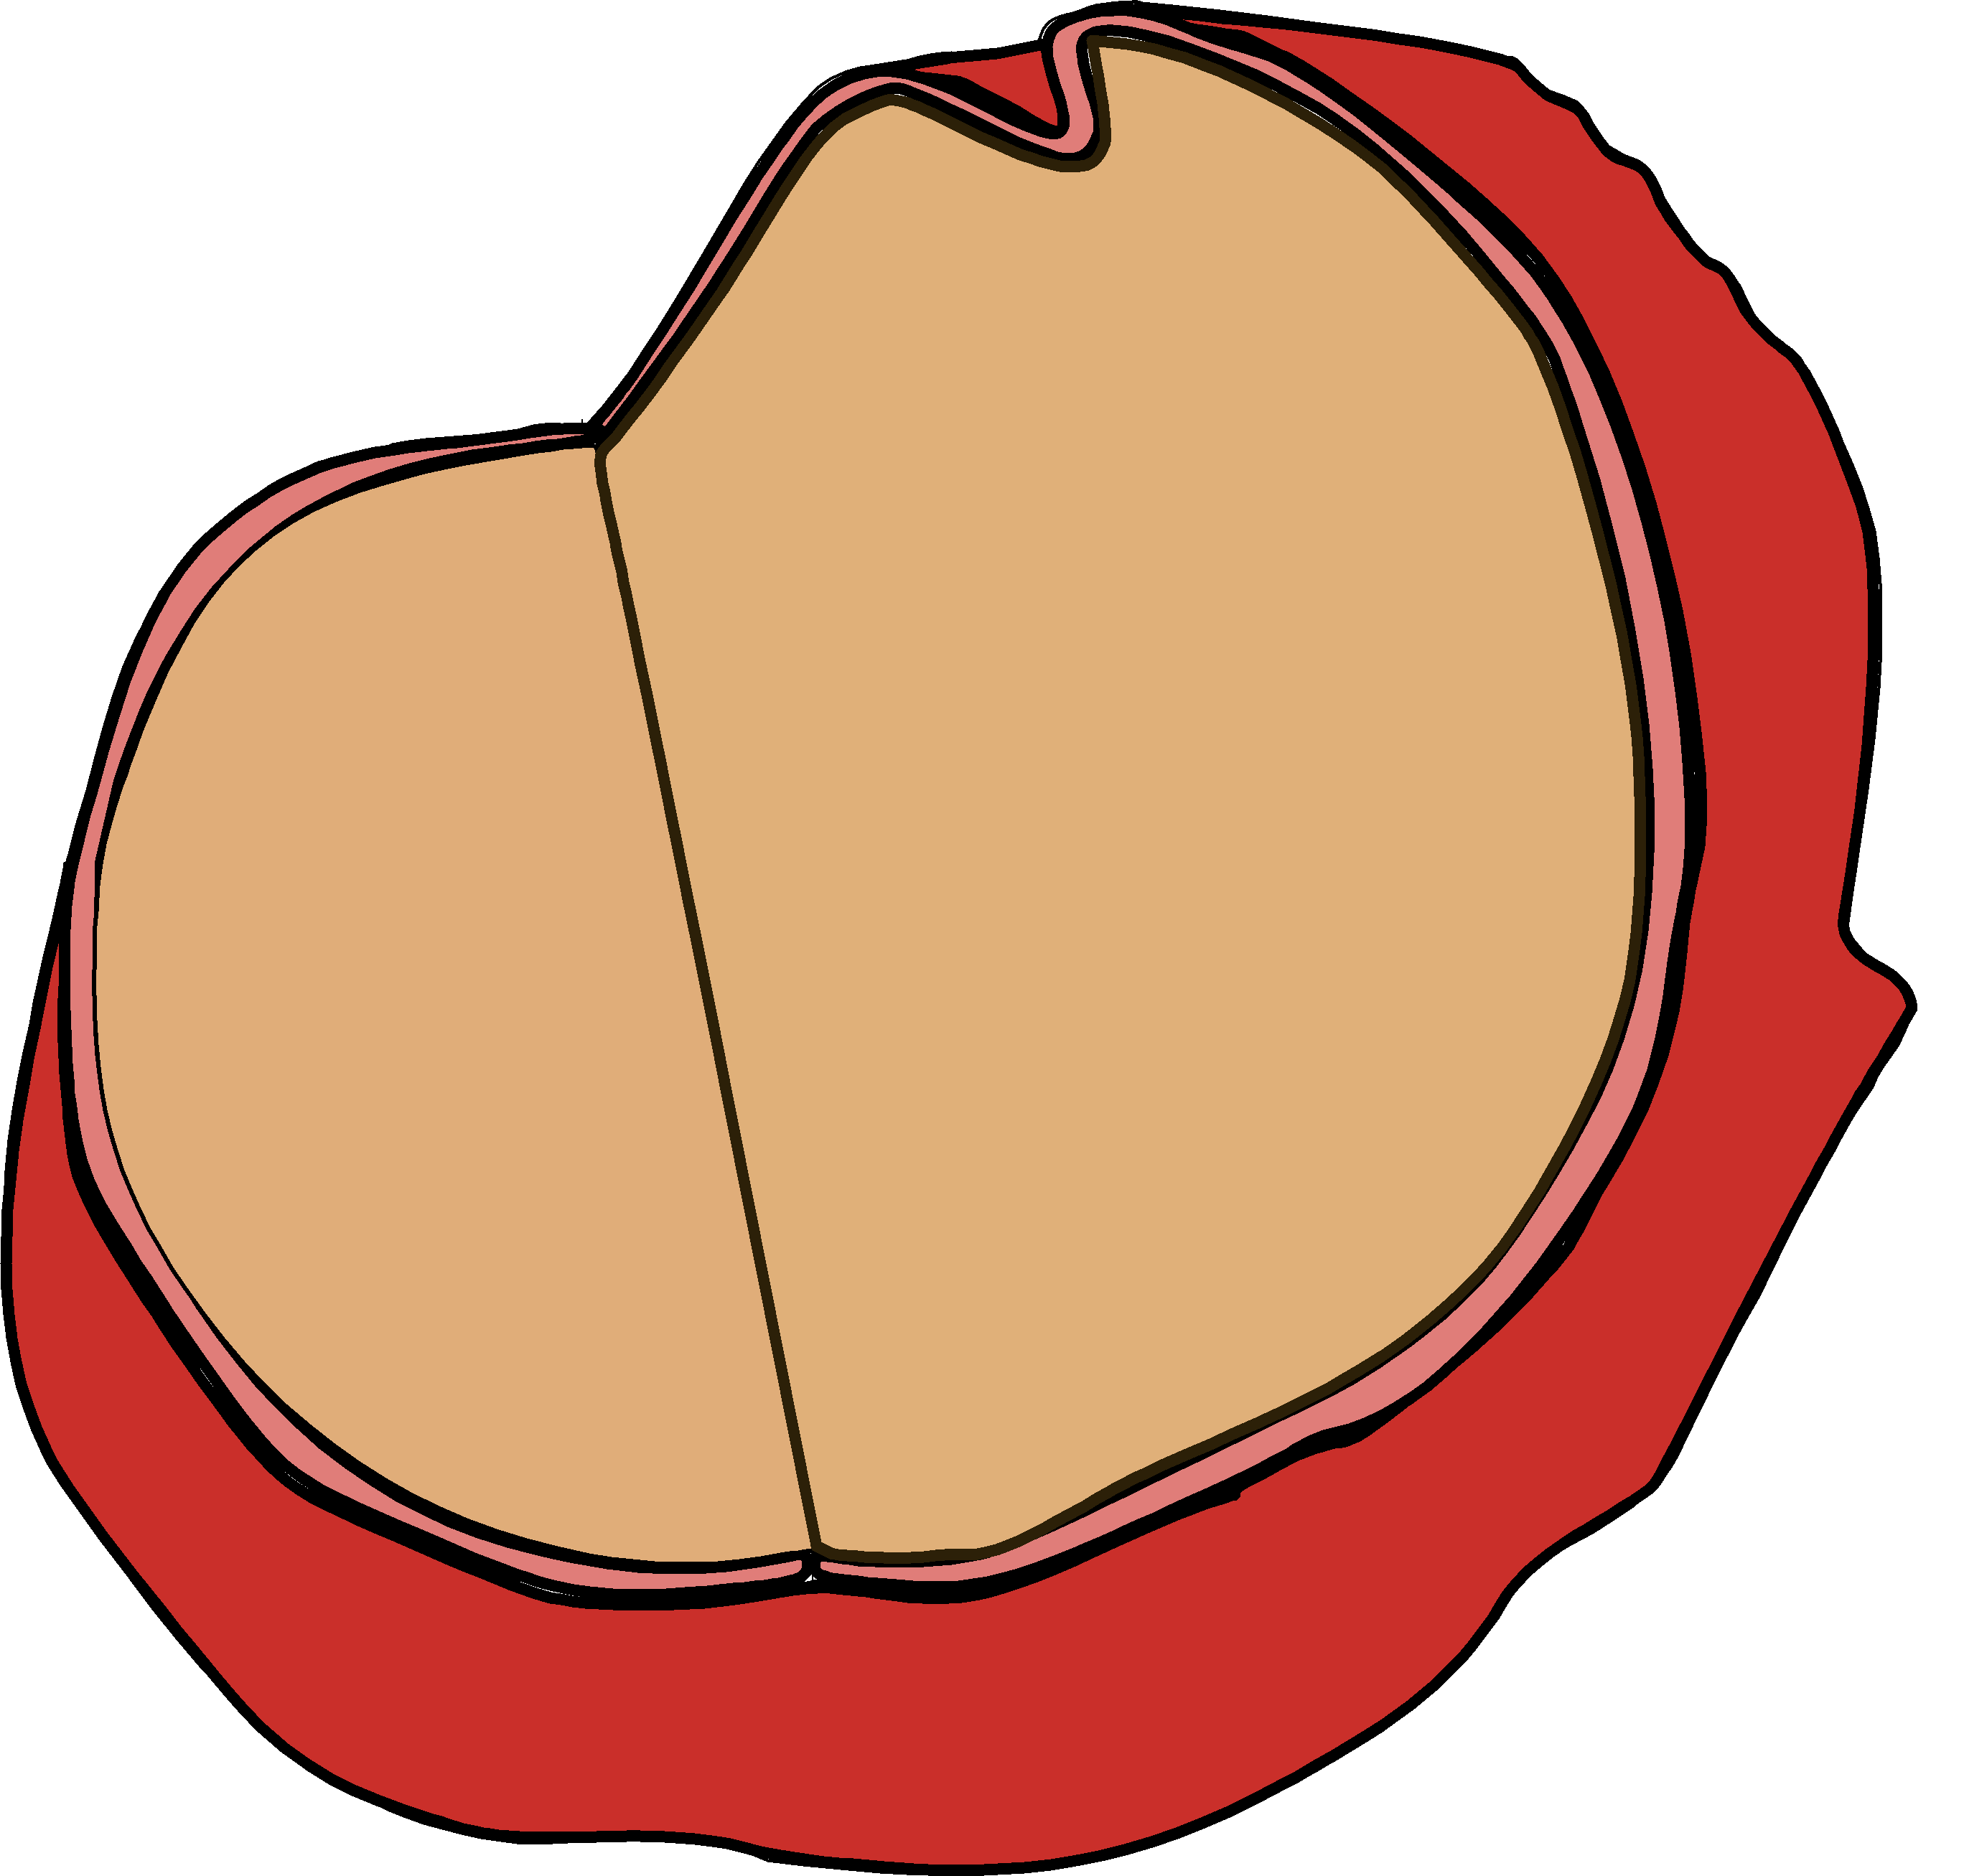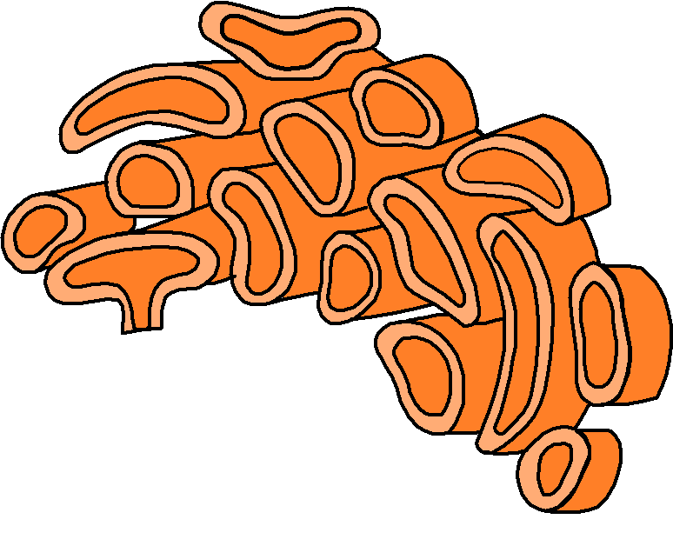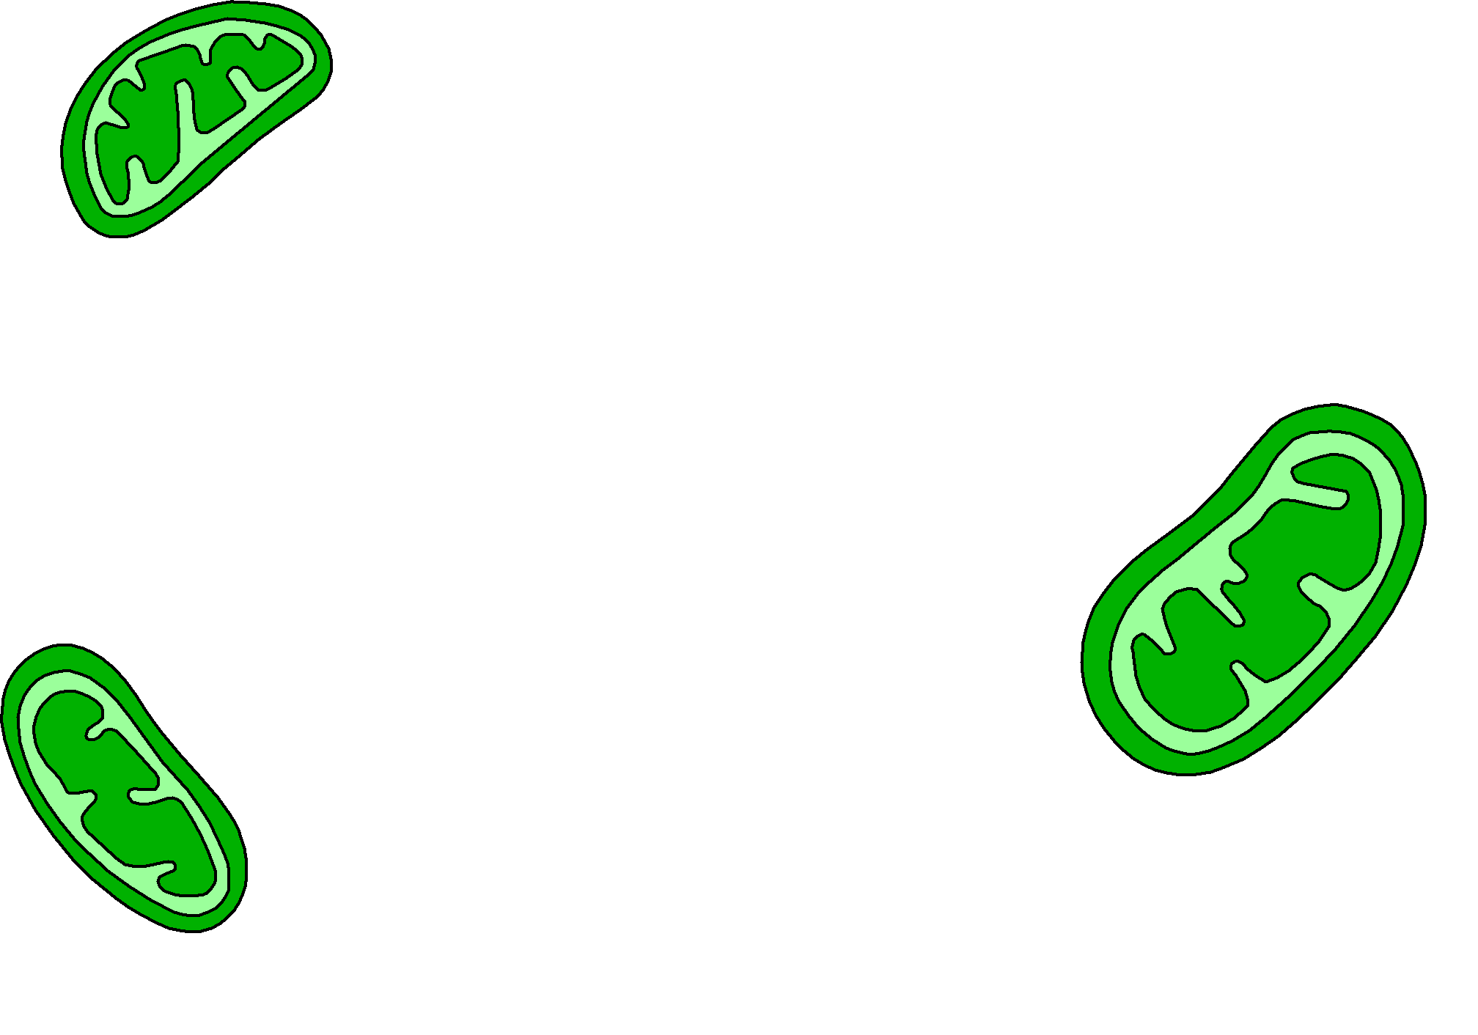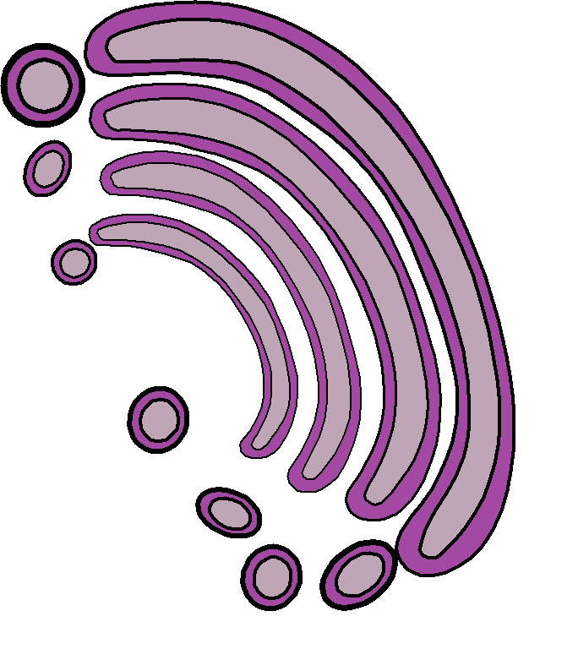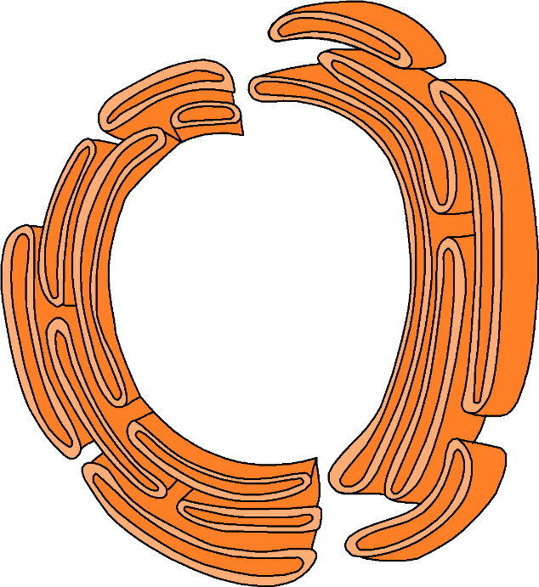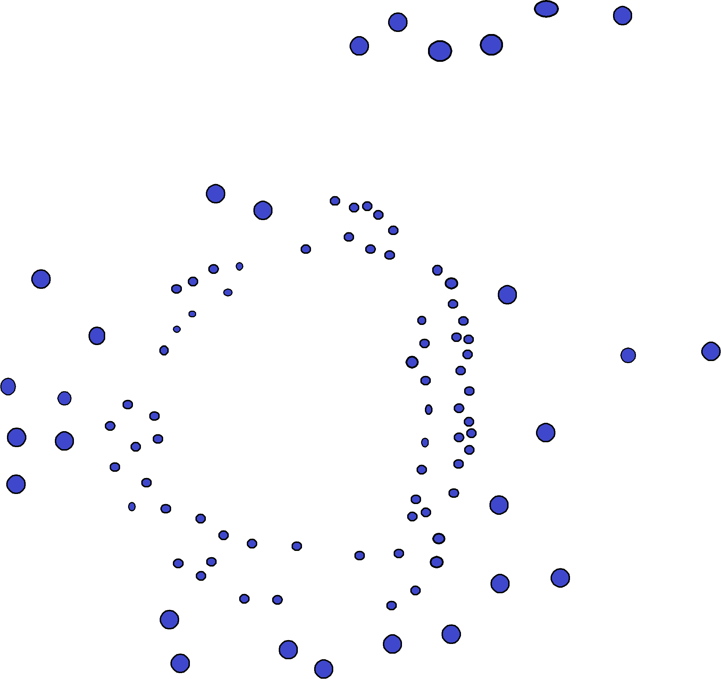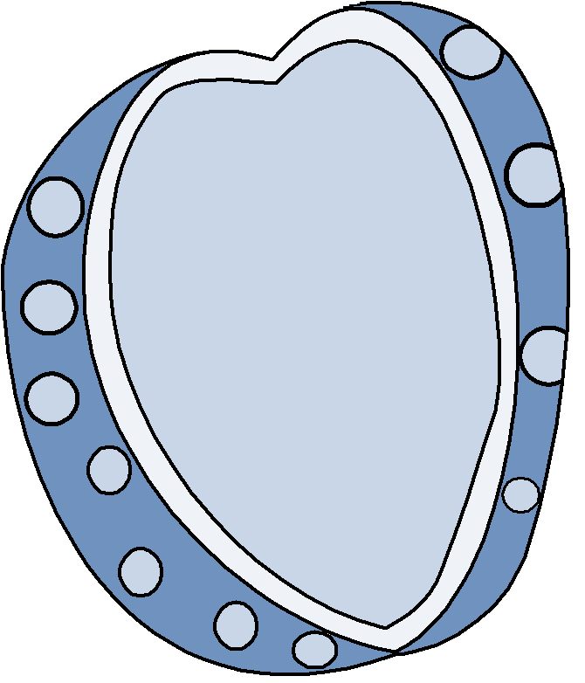

🡪 Organization of Living Organisms

*Please define the levels of organization within living organisms:*

1. Cells:_____________________________________________________________
2. Tissues:___________________________________________________________
3. Organs: __________________________________________________________________
4. Organ Systems: __________________________________________________________________

🡪 Organelles

*Please write the word that best describes the definition below it on the lines provided:*

1. Membranous sacs that contain hydrolytic digestive enzymes.

___________________________________________________

1. Modifies, sorts, and packages proteins from the Endoplasmic Reticulum.

___________________________________________________

1. Packaging system that, combined with the ribosomes, helps make the proteins and membranes for the cell.

___________________________________________________

1. Where rRNA (ribosomal RNA) is synthesized and ribosomes are assembled.

___________________________________________________

🡪 Bonus Questions

1. True or False: Animal cells are prokaryotic _____________________.
2. Where is DNA found in the cell? ______________________________.

**Cells Follow-Along**

ANSWER KEY

1. After looking at the first slide, click Next Page to take a look at the directions for this activity. Read everything the special cell friend is saying. What color will ‘clickable’ words be?

Orange

1. Continue to the Next Page and take a look at the “Building Blocks” listed. On this page there are Atoms, Molecules, and Cells. Read the entire page to fill in the blanks in the following sentences:
   1. Atoms are the basic components of the elements. Everything we see, living and nonliving, is made of atoms.
   2. Atoms combine to form Molecules.
   3. Just like atoms are the building blocks of molecules, molecules are the building blocks of Cells.
2. Click on the link under Atoms that says, “Learn more about atoms!”. Read the information on the Atoms page to answer the following questions:
   1. Just like Cells are the building blocks of living organisms, Atoms are the building blocks of all matter.
   2. Protons carry a positive charge.
   3. Electrons carry a negative charge.
   4. Neutrons carry a neutral charge.
   5. The atom has a Nucleus, which is where the protons and neutrons are found.
   6. The number of Protons an atom has determines what element the atom is.
3. After you have finished the section on Atoms, click the Back button (on the bottom left corner of the slide) to return to the Building Blocks Page again. This time, click on the link above Molecules that says, “Can you guess which molecule this is?”. Read the page about Molecules to fill in the blanks in the following sentences:
   1. Molecules are groups of Atoms held together with a chemical bond (a strong Connection where the atoms share electrons.
4. After you have finished the section on Molecules, click the Back button (on the bottom left corner of the slide) to return to the Building Blocks Page again. This time, click on the link below Cells that says, “What do cells make up?”. Go through the following slides to help you fill in the blanks in the following sentences:
   1. Cells perform the basic functions of life, such as making proteins, processing nutrients, and replicating.
   2. A group of cells with similar jobs combine to form Tissues.
   3. When a group of similar tissues work together to complete a common task, they are called Organs.
5. When you have read through all of the slides on the Cell section, press the Return button (on the bottom left corner of the slide) to get back to the Building Blocks page. From there, press Next Page to arrive at the “Cells Come in All Shapes and Sizes!” page. Press each of the pictures on this page to answer the following fill in the blanks:
   1. Microscopes are tools that we use to see things much too small to see with just our eyes.
   2. Electron microscopes use electron beams to resolve images 10, 100, and even 1000 times smaller than light microscopes.
   3. What are the two main jobs that Fat Cells have: Energy Storage and Temperature Regulation.
   4. Nerve Cells (or Neutrons) are the communication network between the brain and the rest of the body.
   5. Bone Cells make up the skeleton within the bodies of humans and animals.
   6. Name the three types of Bone Cell Tissue that help give bones their strength: Compact tissue, Subchondral tissue, and Cacellous tissue.
   7. Name the four major types of Blood Cells: Red Blood Cells, White Blood Cells, Platelets, and Plasma Cells.
   8. One of the jobs of Blood cells is to take waste to Kidneys and liver to keep the blood and body clean.
6. When you have completed the questions for the Cells Come in All Shapes and Sizes page, click the Next Page button to arrive at the “Inside the Cell” page. From here, select each Red link to look at every organelle and answer the following questions:
   1. The Cell Membrane controls which molecules go in and out of the cell.
   2. The Rough Endoplasmic Reticulum is a network of membranes that have ribosomes attached. It acts as a processing and packaging system that work with ribosomes to make proteins.
   3. The Nucleus is the command center of the cell. You can think of it as the “brain” or the “boss” of the cell.
   4. The Golgi Apparatus receives lipids (fats) and proteins from other organelles. It performs finishing touches with these lipids and proteins such as modifying, sorting, and packaging.
   5. Ribosomes translate genetic information sent out by the nucleus in order to synthesize proteins.
   6. Lysosomes are sacs that contain digestive enzymes. They use the enzymes to break down old organelles and other substances that the cell regards as “trash” into parts that the cell can use again or get rid of.
   7. The Smooth Endoplasmic Reticulum makes lipids (fats) and breaks down toxins.
   8. The cell gets the energy that it uses for all of its tasks from the Mitochondria (Mitochondrion). These are known as the “power-plants” of the cell because they generate energy for the cell from glucose.
   9. The Cytoplasm is a gel-like fluid contained by the cell membrane. This gel is made of water and nutrients used by the cell.
   10. Inside of the nucleus is a concentration of chromosomes surrounded by a double membrane known as the Nucleolus. This is where rRNA and ribosomes are made.
   11. Chromosomes are composed of Proteins, DNA, and RNA. Each Chromosome is made up of a lot of DNA bunched up tightly with proteins that help pack it together.
   12. DNA is short for Deoxyribonucleic Acid.
7. After you have looked at all of the organelles on the Inside the Cell page, click the Next Page button to arrive at the Lesson Review Page. Read this page to answer the following fill in the blanks:
   1. Everything that is matter, including Cells are made of atoms and molecules.
   2. Similar cells work together in groups called Tissues that make up Organs and Organ Systems that perform larger functions for the Organism.

**Cells Worksheet**

ANSWER KEY

🡪 Organelles

1. Keeps in things that the cell wants or needs and keeps everything else out. Cell Membrane
2. Gel-like fluid contained by the cell membrane. Made of water and nutrients used by the cell. Cytoplasm
3. The command center of the cell. Holds the genetic information (DNA) that tells the cells what to do Nucleus
4. Creates ATP, which provides energy needed to power chemical reactions. Also known as the “Power-house” of the cell. Mitochondria (Mitochondrion)
5. Composed of stacks of flattened membrane sacs. Performs finishing touches on proteins from other organelles. Golgi Apparatus
6. The site of protein synthesis (where proteins are made). Ribosomes

🡪 Matter

1. These are the most basic units of all living things: Cells
2. These are the very smallest elements in the universe: Atoms
3. These form when one or more atoms bond together and make a new substance: Molecules

🡪 Organisms

1. B
2. A

**Advanced Cells Worksheet**

ANSWER KEY

🡪 Parts of the Cell

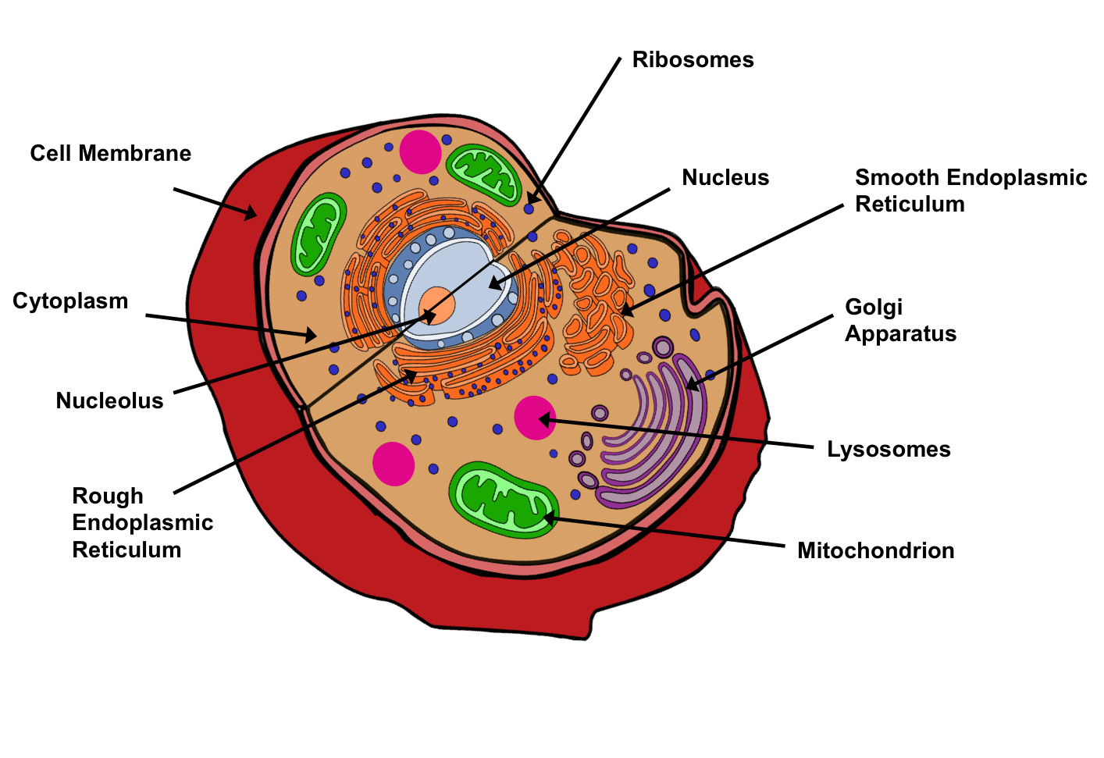

🡪 Organization of Living Organisms

* Cells: Perform the basic functions of life such as making proteins, processing nutrients, and replicating.
* Tissues: When a group of cells with similar jobs combine.
* Organs: When a group of similar tissues work together to complete a common task.
* Organelles: When organs that do similar jobs combine to perform larger functions for the organism.

🡪 Organelles

1. Lysosome
2. Golgi Apparatus
3. Rough Endoplasmic Reticulum
4. Nucleolus

🡪 Bonus Questions

1. False
2. Inside Chromosomes

**Applied Learning Questions**

**(Also Used in the Jeopardy Activity at the conclusion of the online Module)**

**Cells:**

* What types of cells are used primarily for energy storage and temperature regulation? (Fat Cells)
* These types of cells are also known as Adipose Tissue. (Fat Cells)
* Allows the body to function properly when there has been an insufficient level of energy intake or the body is expending high amounts of energy at once. (Fat Storage)
* This type of cell would send Nerve Impulses that would cause you to contract the muscles in your arm and move your hand if you accidentally placed your hand on a hot surface. (Nerve Cells)
* Used to deliver signals to neighboring cells, muscles, and glands? (Axon)
* Part of a Nerve Cell that is stimulated (through light, pressure, etc.) and conducts a signal to the axon. (Dendrites)
* These cells help create the structure and provide the support needed to keep human bodies fully functional. (Bone Cells)
* The hard, outer-layer of the bone is composed of this tissue. (Compact Tissue)
* The smooth tissue at the end of each bone is called? (Subchondral Tissue)
* The spongy tissue inside of the Compact Tissue is known as? (Cancellous Tissue)
* What type of cells helps to fight infections? (Blood cells)
* This type of cell takes waste to the kidneys and liver to be filtered. (Blood Cells)
* What type of cell transports nutrients and oxygen to tissues and the lungs? (Blood Cells)
* Anything that is made up of cells and requires energy to survive. (Living Organism)
* Microscopic, foundational units of all life. (Cells)

**Organelles:**

* Creates a barrier between the inside of the cell and the outside world. (Cell Membrane)
* This substance in animal cells is a gel-like fluid inside the cell membrane. (Cytoplasm)
* This organelle is the commence center of the cell, commonly known as the cell’s “brain”. (Nucleus)
* This organelle is responsible for synthesizing rRNA and assembling ribosomes. (Nucleolus)
* Known as the “powerhouse” of the cell; is responsible for generating energy for the cell. (Mitochondrion or Mitochondria)
* Sorts, modifies, and packages proteins from the Endoplasmic Reticulum and sends them throughout the cell. (Golgi Apparatus)
* Organelles that attach themselves to the Rough Endoplasmic Reticulum and are where protein synthesis (protein building) occurs. (Ribosomes)
* A network of membranes that acts as a packaging system for proteins being made. (Rough Endoplasmic Reticulum)
* Network of membranes that produces lipids (fats) and breaks down toxins. (Smooth Endoplasmic Reticulum)
* Digests worn out organelles and cell debris. (Lysosomes)

**Atoms/Molecules:**

* Which is larger; atoms or cells? (Atoms)
* Which subatomic particle has a neutral charge/no charge? (Neutron)
* True or false: the nucleus of an atom is made up of protons and electrons. (False)
* This value is determined by the number of protons in an atom. (Atomic Number)
* When one or more atoms combine using a chemical bond. (Molecule)

**Tissues/Organs:**

* Tissue that has tightly bound cells that create glands on the linings of organs in the body. (Epithelial Tissue)
* True or False: Organ systems combine to create cells. (False)
* This soft tissue consists of three varieties: skeletal, cardiac, and smooth. Gives muscles their ability to contract. (Muscle Tissue)
* True or False: when tissues combine they create organs. (True)
* Tissue that reacts to stimuli and conducts impulses to various organs that help bring a response to the stimulus. (Nervous Tissue)